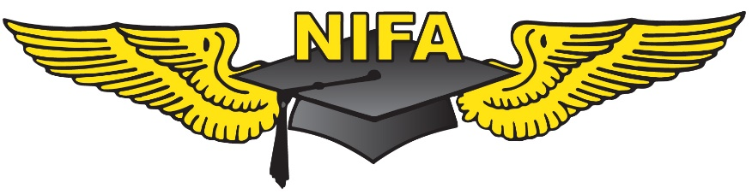

NIFA NATIONAL SAFECON 2014
ACHIEVEMENT AWARDS
Presented for Academic Accomplishments, Aviation Involvement and Community Service

THE WOMEN’S ACHIEVEMENT AWARD
The Ninety-Nines, Inc. International Organization of Women Pilots is the sponsor of the Women’s Achievement Award given annually at the National SAFECON. This prestigious award signifies the Ninety-Nine’s historical support of the National Intercollegiate Flying Association and recognizes the recipient’s academic accomplishments, aviation involvement and community service. Three monetary awards will be presented.

THE MEN’S ACHIEVEMENT AWARD
The Men’s Achievement Award is given annually at the National SAFECON. This prestigious award recognizes the recipient’s academic accomplishments, aviation involvement and community service. Three monetary awards will be presented.

General Requirements:
All candidates for the achievement awards will be interviewed during the National SAFECON by a panel of judges. The applicants will be asked questions and judged in regard to their academic accomplishments, aviation involvement and community service. Financial need and career goals will be taken into consideration. Candidates will be scored on a rating scale of 40 total points.

Achievement Award Candidates:
1. Must hold at least a private pilot certificate.
2. May not be a previous first place winner of the award.
3. Must be a full-time student in good standing.
4. Need not be from a school competing in the National SAFECON.
5. Limited to one male and one female applicant from each NIFA member school.

Application Procedure:
1. Complete the Achievement Award Application available on the NIFA Website or by emailing: carpp99@hotmail.com. no later than Friday, May 9, 2014. Applications must be computer generated.
2. Obtain a letter of recommendation from an instructor or member of the faculty which speaks to academic accomplishments, aviation involvement and community service.
3. Attach a personal résumé.
4. Coaches will schedule Interviews:
- Coaches will schedule Achievement Interviews on Monday, May 12, 2014. It is the responsibility of the coach to inform the applicant(s) of their scheduled interview. A cell phone number must be listed for each coach and applicant, in case of last minute schedule changes.
- Applications must be turned in to the Achievement Judges or Comm Desk by 5:00 PM on Monday, May 12, 2014 or students will not be interviewed. All documents must be computer generated. The interview judges must be able to read and review applications before the interview.
5. Interviews will be scheduled Tuesday through Thursday, between the hours of 8:00 AM and 5:00 PM. Candidates who miss their scheduled appointments may reschedule with the Achievement Judges at convenient available times until 5:00 PM Thursday. Interviews delayed until Friday morning will be scheduled in consultation with the Chief Judge.

Note: Remove this cover sheet when submitting your application.
NIFA SAFECON 2014
ACHIEVEMENT AWARD APPLICATION

Presented for Academic Accomplishments, Aviation Involvement and Community Service

(check one)
The Men’s Achievement Award The Women’s Achievement Award

Click here to enter text.
Name
Click here to enter text.
Address
Click here to enter text.
City, State, Zip
Click here to enter text.
E-Mail Address
Click here to enter text.
Cell Phone
Click here to enter text.
School Address
Click here to enter text.
Address
Click here to enter text.
City, State, Zip
Click here to enter text.
School Phone Number
Click here to enter text.
Team Name

1. Academic Accomplishments

Click here to enter text. | Click here to enter text. | Click here to enter text. | Click here to enter text.
Year in School  (Ex: Sophomore, Junior, Senior, Graduate) | GPA | Major | Minor

Have you applied before? Yes No If yes,when? Click here to enter text.

How are you financing your education and flying?
Click here to enter text.

Campus Activities & Organizations NOT related to flying:
Click here to enter text.
Awards/ Honors Received NOT related to flying:
Click here to enter text.

2. Aviation Involvement
PILOT CERTIFICATES and RATINGS:
Certificate Number | Total Hours | Ratings | Other Certificates
Click to enter text. | Click to enter text. | Click to enter text. | Click to enter text.

When did you learn to fly? Click to enter text.
Location: Click to enter text.

NIFA PARTICIPATION:
Regional SAFECONS Entered | National SAFECONS Entered | Events Entered in this National SAFECON
Click to enter text. | Click to enter text. | Click to enter text.

FLYING:
Memberships in Aviation Organizations/Flying Clubs:
Click to enter text.

Offices Held and Awards Received:
Click to enter text.

Flying-Related Activities:
Click to enter text.

Future Plans and Career Goals:
Click to enter text.
3. Community Service
Community Service initiated by organizations or groups:
Click to enter text.

Community Service initiated by the applicant:
Click to enter text.

Future Plans for Community Service:
Click to enter text.

4. Additional Information

Please list any additional achievements or accomplishments you feel appropriate for this award. You may also use the back of this page or attach additional pages. Thank you!
Click to enter text.

Attach Letter of Recommendation and Resumé.

Interview Appointments will be scheduled by coaches on Monday, May 12, 2014
Completed Applications must be turned in to the Achievement Judges or Comm Desk immediately following the scheduling of the interview or no later than 5:00 PM, May 12, 2014.

